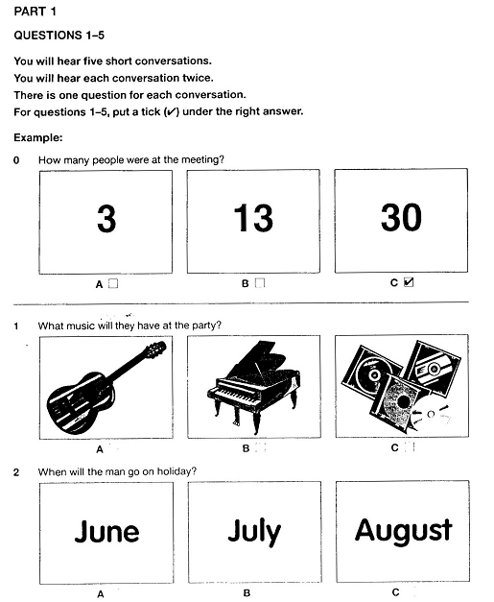
LISTENING PART 1 – KET EXAM

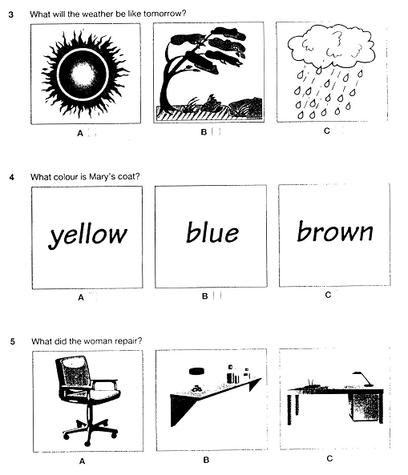

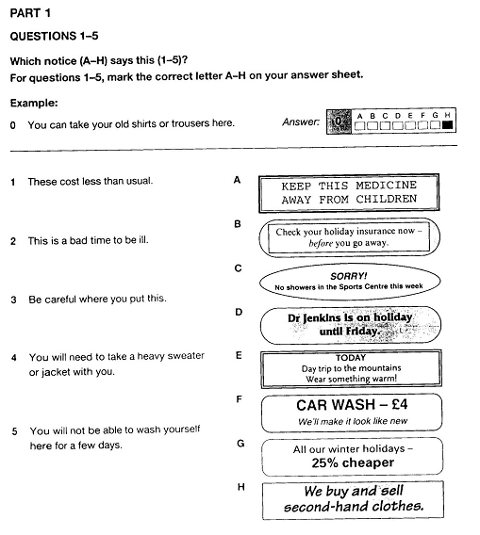
READING PART 1 – KET EXAM

ANSWER KEYS
- LISTENING PART:

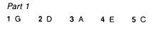
- LISTENING PART:

Source:
Cambridge ESOL. 2004. Cambridge English KET 1. Cambridge University Press.

